WEEK-2
MODULE 6 – 3.SPRING DATA JPA AND HIBERNATE HANDSON

NAME : ANANTH KARTHIK V
SUPERSET ID : 6738185

Objective 1: Demonstrate Writing Hibernate Query Language (HQL) and Native Query:

Hibernate and Spring Data JPA provide different ways to query data:
HQL (Hibernate Query Language) – A SQL-like language that uses entity class names and properties.
JPQL (Java Persistence Query Language) – The standardized version specified by JPA; very similar to HQL.
Native Query – Direct SQL statements executed against the underlying database.
1. HQL / JPQL Basics
These queries are written using entity class and field names:
@Query("SELECT e FROM Employee e WHERE e.salary > :minSalary")
List<Employee> findEmployeesWithSalaryAbove(@Param("minSalary") double minSalary);
"Employee” is the entity class.
"salary” refers to the Java field.
This is portable across databases, unlike SQL.
2. HQL with FETCH Keyword
@Query("SELECT d FROM Department d JOIN FETCH d.employees WHERE d.name = :deptName")
Department findDepartmentWithEmployees(@Param("deptName") String deptName);
JOIN FETCH ensures that associated employees are retrieved in the same query.
3. HQL Aggregate Functions
@Query("SELECT AVG(e.salary) FROM Employee e")
Double findAverageSalary();
Supported functions: COUNT(), SUM(), AVG(), MAX(), MIN().
4. Native Query Example
Sometimes, we need raw SQL queries, especially for performance or complex DB-specific queries:
@Query(value = "SELECT * FROM employee WHERE salary > ?1", nativeQuery = true)
List<Employee> findHighSalaryEmployees(double minSalary);
Use nativeQuery = true to indicate that this is raw SQL.
Table and column identifiers must exactly match your schema.
Implementation:
Employee.java:
package com.example.hqlnativequery.model;
import jakarta.persistence.*;
@Entity
public class Employee {
@Id
@GeneratedValue(strategy = GenerationType.IDENTITY)
private Long id;
private String name;
private double salary;
public Employee() {
}

public Employee(String name, double salary) {
this.name = name;
this.salary = salary;
}

@Override
public String toString() {
return "Employee{" +
"id=" + id +
", name='" + name + '\'' +
", salary=" + salary +
'}';
}
}
EmployeeRepository.java:
package com.example.hqlnativequery.repository;
import com.example.hqlnativequery.model.Employee;
import org.springframework.data.jpa.repository.JpaRepository;
import org.springframework.data.jpa.repository.Query;
import java.util.List;

public interface EmployeeRepository
extends JpaRepository<Employee, Long> {

@Query("FROM Employee")
List<Employee> getAllEmployees();

@Query("FROM Employee e WHERE e.salary > ?1")
List<Employee> getEmployeesAboveSalary(double salary);

@Query("SELECT AVG(e.salary) FROM Employee e")
Double getAverageSalary();
@Query(
value = "SELECT * FROM employee WHERE salary < ?1",
nativeQuery = true
)
List<Employee> getEmployeesBelowSalary(double salary);
}
DataRunner.java:
package com.example.hqlnativequery.runner;
import com.example.hqlnativequery.model.Employee;
import com.example.hqlnativequery.repository.EmployeeRepository;
import org.springframework.boot.CommandLineRunner;
import org.springframework.stereotype.Component;

@Component
public class DataRunner implements CommandLineRunner {

private final EmployeeRepository repository;
public DataRunner(EmployeeRepository repository) {
this.repository = repository;
}
@Override
public void run(String... args) {
repository.save(new Employee("Ananth", 50000));
repository.save(new Employee("Praban", 70000));
repository.save(new Employee("Karthik", 60000));

System.out.println("\n===== HQL Query =====");
repository.getAllEmployees()
.forEach(System.out::println);

System.out.println("\n===== Salary > 55000 =====");
repository.getEmployeesAboveSalary(55000)
.forEach(System.out::println);

System.out.println("\n===== Average Salary =====");
System.out.println(repository.getAverageSalary());

System.out.println("\n===== Native Query =====");
repository.getEmployeesBelowSalary(65000)
.forEach(System.out::println);
}
}
HqlnativequeryApplication.java:
package com.example.hqlnativequery;
import org.springframework.boot.SpringApplication;
import org.springframework.boot.autoconfigure.SpringBootApplication;
@SpringBootApplication
public class HqlnativequeryApplication {
public static void main(String[] args) {
SpringApplication.run(HqlnativequeryApplication.class, args);
}
}
Output:
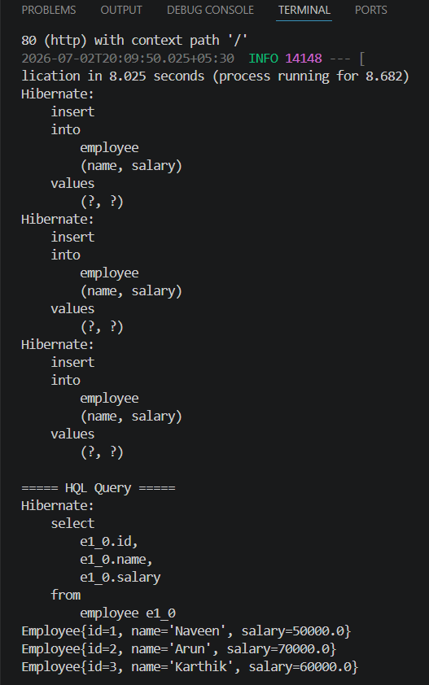
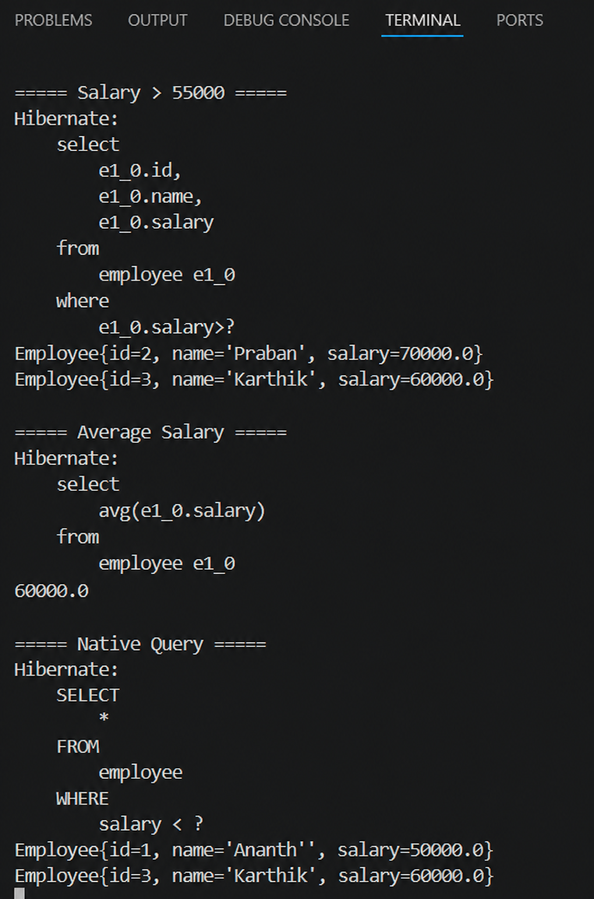

Objective 2: Explain the Need and Benefit of Criteria Query

Sometimes, we need to build queries dynamically based on user input or application logic. Writing raw HQL/JPQL in such cases can get messy. That’s where Criteria API comes in.
Dynamic query building (e.g., filters based on input fields).
Type-safe queries at compile-time.
No need to construct long string-based queries.
Easily reusable and maintainable.
Core Components of Criteria Query:
- CriteriaBuilder – Factory for creating criteria queries.
- CriteriaQuery<T> – Represents the query object.
- Root<T> – Defines the main entity/table being queried.
- TypedQuery<T> – Final query to be executed.
Example: Find employees with dynamic salary range
CriteriaBuilder cb = entityManager.getCriteriaBuilder();
CriteriaQuery<Employee> query = cb.createQuery(Employee.class);
Root<Employee> root = query.from(Employee.class);
query.select(root).where(cb.between(root.get("salary"), 30000, 60000));
TypedQuery<Employee> typedQuery = entityManager.createQuery(query);
List<Employee> result = typedQuery.getResultList();
This avoids manual string construction.
Fields like "salary" are checked by the compiler, reducing runtime errors.

